ORDER SHEET ORDER DATE ORDER #

CUSTOMER DETAILS

CUSTOMER NAME COMPANY

SHIPPING ADDRESS TEL

EMAIL

ITEM #

ORDER DETAILS
ITEM QTY PRICE DISCOUNT TOTAL PRICE

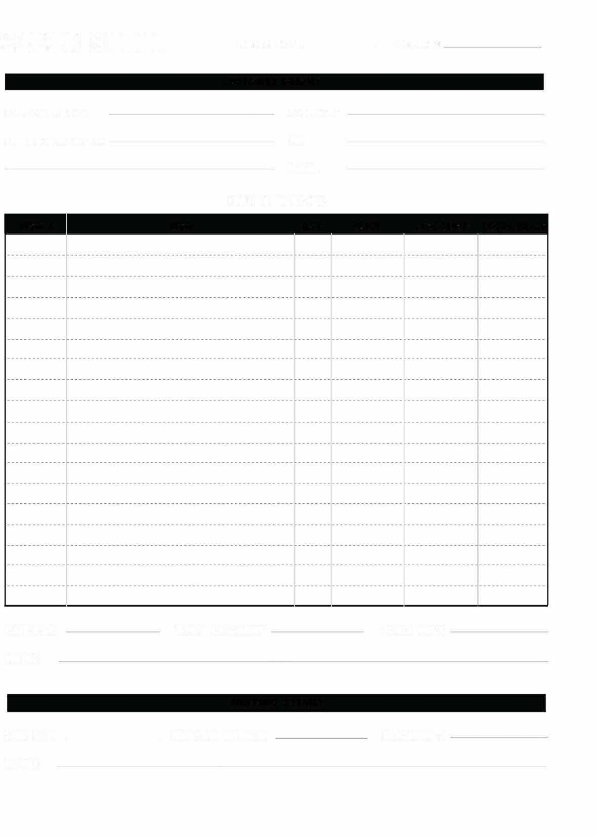
B
Begonia Whopper Big Green Leaf Red Flower $5

Petunia Red, White, Blue $5

Vinca Red, White, Pink, Lavender. $5

Geranium Red, Pink. $5

DATE PAID TOTAL DISCOUNT TOTAL PRICE NOTES

SHIPPING DETAILS

SHIP DATE SHIPPING METHOD TR ACKING #

NOTES

